

Practices for Secure Software Report

Table of Contents
Document Revision History 3
Client 3
Instructions 3
Developer 4
1. Algorithm Cipher 4
2. Certificate Generation 4
3. Deploy Cipher 4
4. Secure Communications 4
5. Secondary Testing 4
6. Functional Testing 4
7. Summary 4
8. Industry Standard Best Practices 4

Document Revision History

Version | Date | Author | Comments
1.0 | [Date] | [Your Name]

Client



Instructions

Submit this completed practices for secure software report. Replace the bracketed text with the relevant information. You must document your process for writing secure communications and refactoring code that complies with software security testing protocols.

- Respond to the steps outlined below and include your findings.
- Respond using your own words. You may also choose to include images or supporting materials. If you include them, make certain to insert them in all the relevant locations in the document.
- Refer to the Project Two Guidelines and Rubric for more detailed instructions about each section of the template.

Developer
Michael Conrad

Algorithm Cipher

High-Level Overview SHA-256 is a cryptographic hash algorithm that takes any input data and produces a fixed-size 256-bit (32-byte) output called a hash or digest. It is a one-way function, meaning you cannot reverse the hash back to the original data. It is widely used for data integrity verification, digital signatures, and SSL/TLS certificates which makes it a perfect fit for Artemis Financial's needs.

Hash Functions and Bit Levels SHA-256 produces a 256-bit hash value, represented as a 64-character hexadecimal string. It processes data in 512-bit blocks and uses 64 rounds of compression operations per block. The larger the bit level, the more resistant it is to brute-force and collision attacks.

Random Numbers, Symmetric vs. Asymmetric Keys SHA-256 itself is not an encryption algorithm it doesn't use keys. However, in your project it works alongside asymmetric encryption (the SSL/TLS certificate). Your keystore uses asymmetric keys (a public/private key pair) to secure the HTTPS connection, while SHA-256 handles the checksum/integrity verification. Asymmetric encryption is slower but more secure for key exchange; symmetric encryption is faster and used for bulk data transfer after the handshake.

History and Current State SHA-256 was published by the NSA and NIST in 2001 as part of the SHA-2 family, developed in response to weaknesses found in the older SHA-1 algorithm. SHA-1 was officially deprecated by NIST in 2011 and is no longer considered secure. SHA-256 remains the industry standard today and is trusted by governments, banks, and tech companies worldwide. It has no known practical collision vulnerabilities, making it one of the most reliable hashing algorithms currently available.

Certificate Generation
Insert a screenshot below of the CER file.

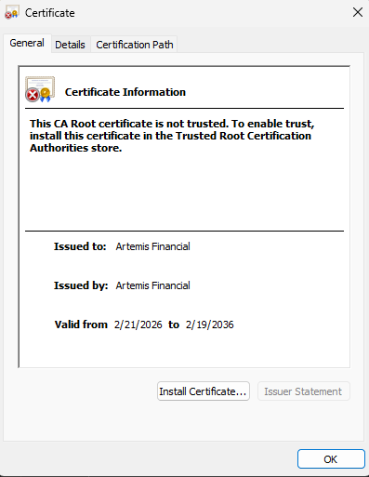

Deploy Cipher
Insert a screenshot below of the checksum verification.

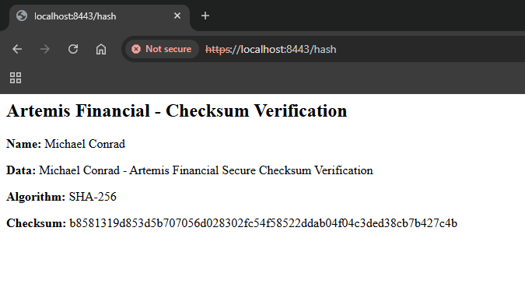

Secure Communications
Insert a screenshot below of the web browser that shows a secure webpage.

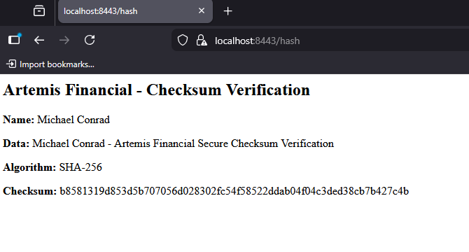

Secondary Testing
Insert screenshots below of the refactored code executed without errors and the dependency-check report.

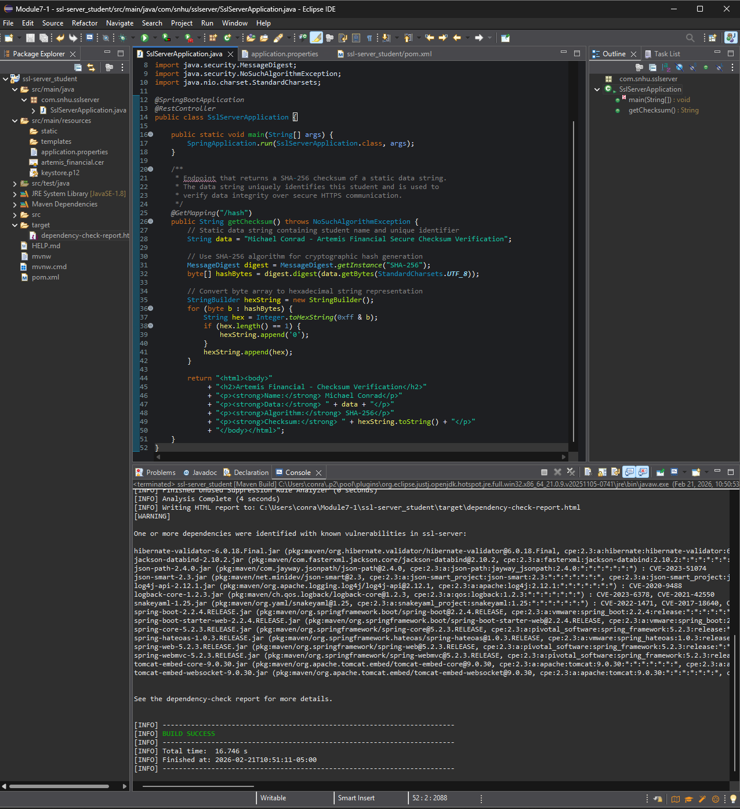
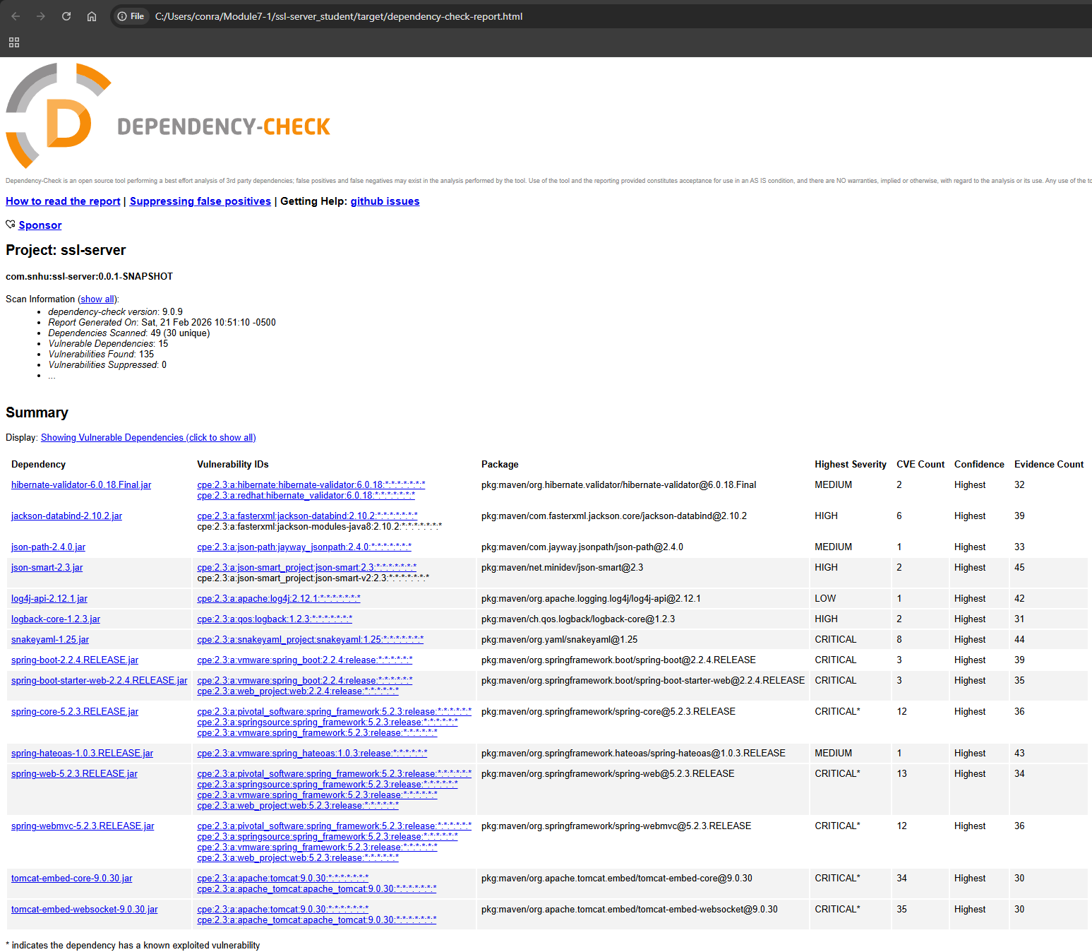

Functional Testing
Insert a screenshot below of the refactored code executed without errors.

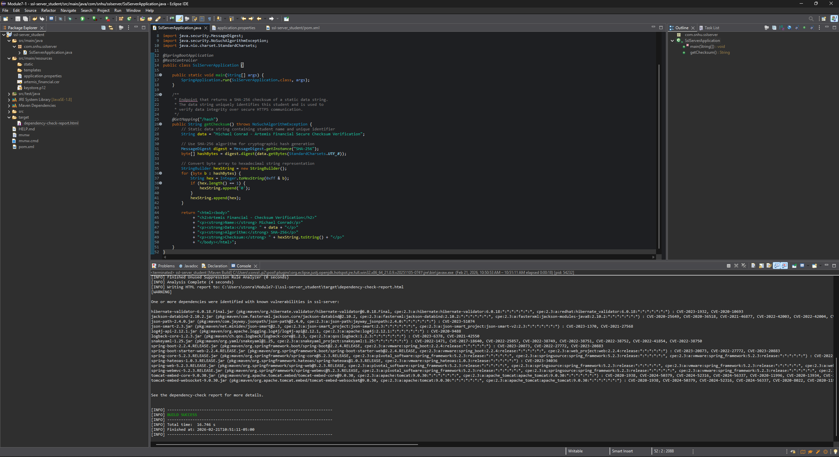

Summary

The refactoring of Artemis Financial's software application focused on addressing several critical areas of security to ensure that client data and financial information are protected. The vulnerability assessment process identified the need for stronger data integrity verification and secure communication protocols. To address these vulnerabilities, the code was refactored to implement a SHA-256 cryptographic hash algorithm, which generates a unique checksum to verify that data has not been tampered with during transmission. Additionally, the application was converted from HTTP to HTTPS by configuring SSL/TLS through a PKCS12 keystore and a self-signed certificate generated using the Java Keytool. These changes directly address the cryptography and secure communication layers of the vulnerability assessment process flow.

The layers of security added through refactoring include encrypted communication via HTTPS, data integrity verification via SHA-256 checksum, and certificate-based authentication via the SSL keystore. Together these layers ensure that data transmitted between the client and the server is both encrypted and verifiable, significantly reducing the risk of man-in-the-middle attacks, data interception, and data tampering.

Industry Standard Best Practices

Industry standard best practices were applied throughout the refactoring process to ensure that Artemis Financial's software meets current security standards. SHA-256 was selected as the hashing algorithm because it is approved by the National Institute of Standards and Technology (NIST) and is widely recognized as one of the most secure and reliable hashing algorithms available today. It has no known practical collision vulnerabilities, making it ideal for financial data integrity verification. The HTTPS protocol was implemented using TLS, which is the industry standard for encrypting data in transit and is required by virtually all modern security frameworks and compliance standards. The PKCS12 keystore format used to store the SSL certificate is also an industry standard format supported across all major platforms and programming languages.

Applying these industry standard best practices provides significant value to Artemis Financial's overall well-being. By using proven, widely accepted security technologies, the company reduces its exposure to known vulnerabilities and demonstrates a commitment to protecting client data. This builds customer trust, supports regulatory compliance, and reduces the financial and reputational risk that would result from a data breach. Secure coding practices also reduce long-term maintenance costs by making the application more resilient and easier to audit, ensuring that security remains a foundation of the software rather than an afterthought.

